**In-class exercises**

Consider the following data, decision boundary, and margin boundaries.

[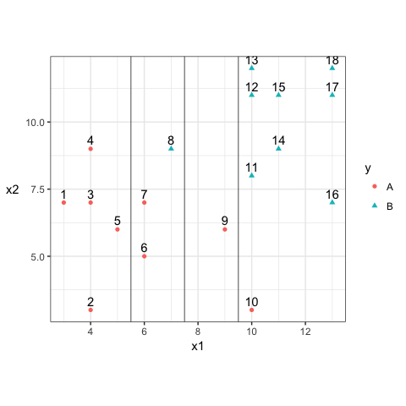](https://github.com/vincenzocoia/BAIT509/blob/master/class_meetings/cm09-svm_files/figure-html/unnamed-chunk-7-1.png)

1. Construct the decision rule according to this classification boundary. How would you classify a new observation that has $x_1=6$ and $x_2=10$?

Answer: The decision rule according to this classification boundary is X1<7.5 and 1>7.5. A new observation that has X1 = 6 and X2 = 10 will be classified as A simply because its X1 = 6 < 7.5.

1. What size is the margin here?

Answer: The size of the margin is 2 unit on the x-axis.

1. Which observations receive a penalty? Which observations are the support vectors?

Answer: observation 6, 7, 8, 9, 10 receive penalty. And the observation 6, 7, 8, 9, 10 are the support vectors.

1. What is the total penalty here?

Answer: The total penalty equals the penalty of each observation of 6, 7, 8, 9 and 10.

Penalty for 6: 0.5/2 = 0.25 (margin width)

Penalty for 7: 0.5/2 = 0.25

Penalty for 8: 2.5/2 =1.25

Penalty for 9: 3.5/2 = 1.75

Penalty for 10: 4.5/2 = 2.25

Therefore, the total penalty is : 0.25 + 0.25 + 1.25 + 1.75 + 2.25 = 5.75

1. Can I choose a bigger margin if my total allowable penalty is 6?

Answer: Yes but not too much. As the current penalty is 5.75, choosing a bigger margin will increase the penalty. If the total allowable penalty is 6,there is only 0.25 unit of margin that can be added.

Hard to say because the error will decrease first and then increase with the increase of margin width. It really depends on whether the current penalty 5.75 is located to the left or right of the minimum level of the data. Further test must be conducted to examine which direction will the total penalty go with slight increase of the margin width.

1. Are the data separable? If so, what are the support vectors?

Answer: Yes. The ideal support vectors are observation 4, 8 and 9.